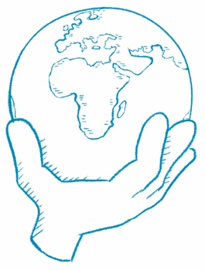
What Can You Do?
Article Title

Answer the question at the end of the article.
Draw or write.

