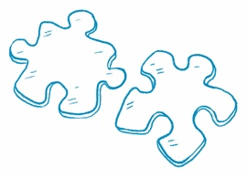
How Do They Compare?
Compare Information Find two news articles about
similar topics. Read each article and answer the questions.
Article 1 Title | Article 2 Title
What is the main idea? | What is the main idea?
What are the key details? | What are the key details?
What is the same about both articles?

